**iReasoning MIB Browser Instructions**

The forwarding information of all SNMP nodes can be easily searched using SNMP MIB software, taking iReasoning MIB Browser software as an example.

You can download it from website: http://www.ireasoning.com/download.shtml.

**1. Install**

Install iReasoning Mib-Browser software.

 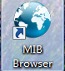

**2.** **Import mib file**

Import the S_Gate.mib file ,as follows.

Note: The directory path for MIb files should not be too long, and the directory name should not be used in any language other than English.

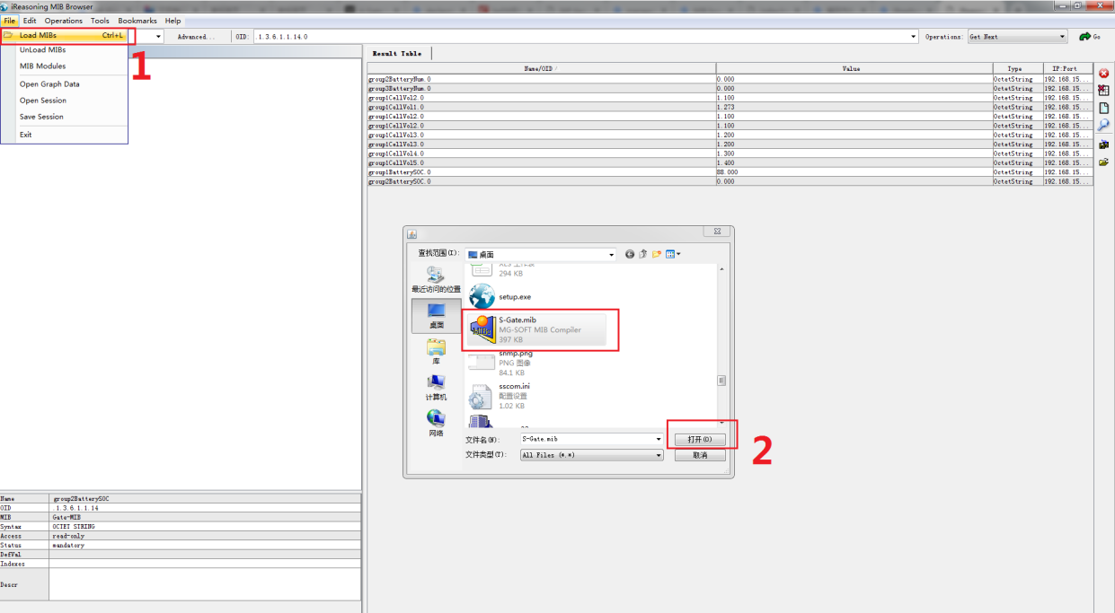

**3.** **Get oid value**

1. input the pbat-gate ip;

2. get the oid value;

3. view the oid value;

